DRAFT E
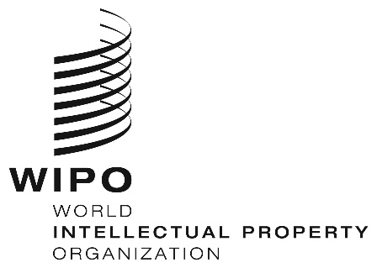
ORIGINAL: English / chinese
DATE: April 28, 2017

The Workshop on Intellectual Property Protection
with Focus on Madrid International Registration System for Marks

Organized by ：
World Intellectual Property Organization (WIPO)
State Administration for Industry and Commerce (SAIC)

Undertaken by：
WIPO Office in China (WOC)
China Trademark Association (CTA)

Chengdu City, Sichuan Province

June 1 and 2, 2017

provisional Program

prepared by the World Intellectual Property Organization Office in China

June 1, Thursday

08:00～08:30 Registration

08:30～08:45 Opening Ceremony by:
Mr Chen Hongbing, Director of WIPO Office in China (WOC)
Mr Wang Peizhang, Director General of China Trademark Association

08:45～10:15 How to encourage Chinese enterprises to protect IP abroad
Speaker: Representative from CTMO

10:15～10:30 Coffee Break
10:30～12:00 Overview of International Protection for Marks through the Madrid System
Speaker: Ms Zhang Junqin, National Program Officer, WOC

12:00～12:15 Questions and Answers

12:15～14:00 Working Lunch

14:00～15:30 Viewpoints and Experiences on Protecting Trademarks Abroad
Speaker: Representative from CHOFA IP

15:30～15:45 Coffee Break

15:45～17:15 Foreign counterpart’s practice and suggestions on the use of Madrid System
Speaker: Mr Bernard Volken, Fuhrer Marbach & Partners, Switzerland

17:15～18:00 Questions and Answers

June 2, Friday

9:00～10:30 Practice Tips- The International Application and the Examination
Speaker: Representative from International Registration Division
China Trademark Office (CTMO)

10:30～11:00 Q&A and Discussion

11:00～11:30 Closing

[End of document]

商标国际注册与保护高级研修班
议程(草案)
（6月1日上午-2日上午）
主办：世界知识产权组织（WIPO）中国办事处
中华商标协会
支持：国家工商总局国际合作司
国家工商总局商标局

Date and Time  时间 | Program  内容
June 1  08:00～08:30 | Registration  报到
08:30～08:45 | Opening Ceremony:开幕致辞  Mr Chen Hongbing, Director of WIPO Office in China (WOC)  陈宏兵，WIPO 中国办事处主任  Mr Wang Peizhang, Director General of China Trademark Association  王培章，中华商标协会秘书长
08:45～10:15 | Topic 1:How to encourage Chinese enterprises to protect IP abroad  如何鼓励中国企业寻求海外知识产权保护  Speaker 1:  演讲人1：  Representative from CTMO  国家工商行政管理总局商标局代表
10:15～10:30 | Coffee Break茶歇
10:30—12:00 | Topic 2:Overview of International Protection for Marks through the Madrid System  演讲2：通过马德里体系促进商标国际保护概述  Speaker 2:  演讲人2：  Speaker: Ms Zhang Junqin, National Program Officer, WOC  张俊琴，WIPO 中国办事处国家项目官员合伙人
12:00～12:15 | Questions and Answers问答
12:15～14:00 | Lunch  午餐
14:00～15:30 | Topic 3: Viewpoints and Experiences on Protecting Trademarks Abroad  演讲3：商标国际保护的经验分享  Speaker 3:  演讲人3：  Representative from CHOFA IP  CHOFA知识产权代理代表
15:30～15:45 | Coffee Break茶歇
15:45～17:15 | Topic 4: Foreign counterpart’s practice and suggestions on the use of Madrid System  演讲4：外国专家对马德里体系使用者的经验和建议  Speaker 4:  演讲人4：  Mr Bernard Volken, Fuhrer Marbach & Partners, Switzerland  Bernard Volken，Fuhrer Marbach & Partners公司合伙人
17:15～18:00 | Questions and Answers:问答
June 2  9:00～10:30 | Topic 5: Practice Tips- The International Application and the Examination  演讲5：国际申请与审查  Speaker 5:  演讲人5：  Representative from International Registration Division  China Trademark Office(CTMO)  State Administration for Industry and Commerce(SAIC)  国家工商行政管理总局商标局国际注册处代表
10:30～11:00 | Q&A and Discussion问答
11:00～11:30 | Closing  闭幕式

